**LAB#13**

**OBJECT: Implement the circuit diagram of gray code to binary conversion.**

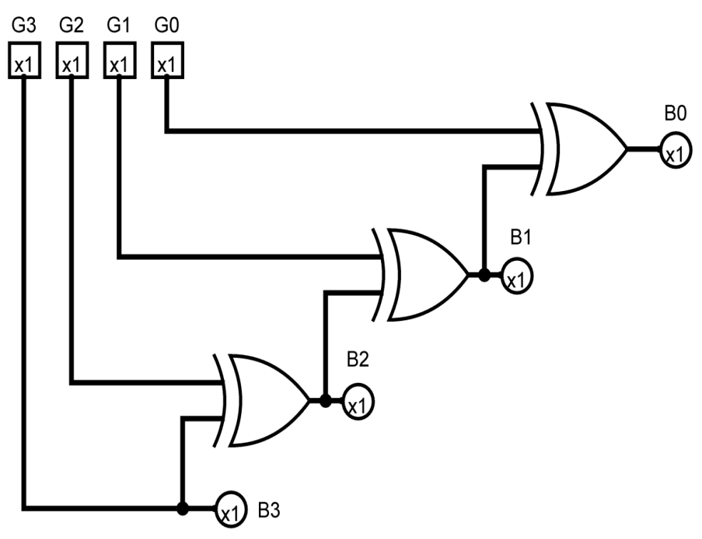

**APPARATUS:**

* 74LS86
* Bread Board
* Connecting Wires
* LED
* DC Supply

**SYMBOLS:**

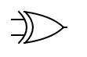

XOR GATE

**CIRCUIT DESIGN:**

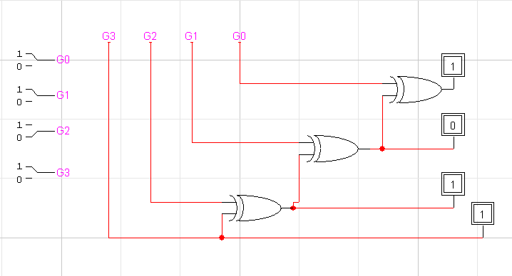

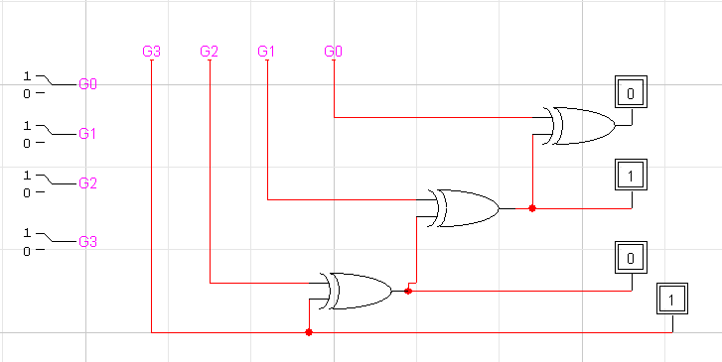

**CONCLUSION:**

The Gray Code to Binary conversion is accurate.